Name : Manava Dhar

Roll no: 2310030086

Question : Deploying a Windows Server in a Public Subnet and Accessing from a Local Machine

Steps:

1. Log in to your AWS free tier account

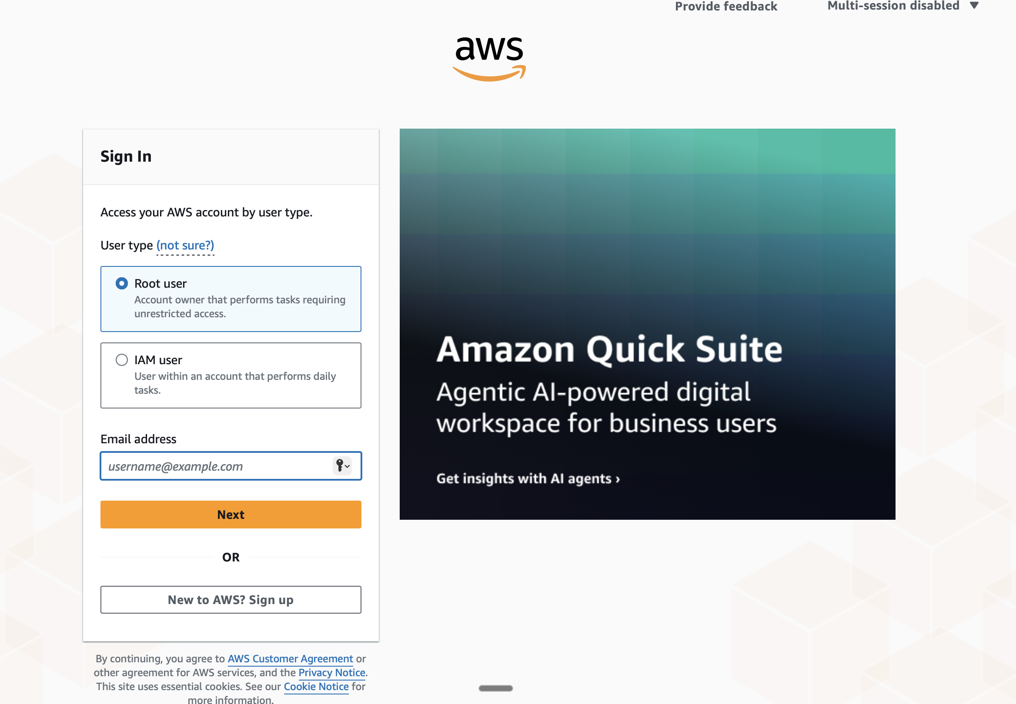

1. Go to VPC services

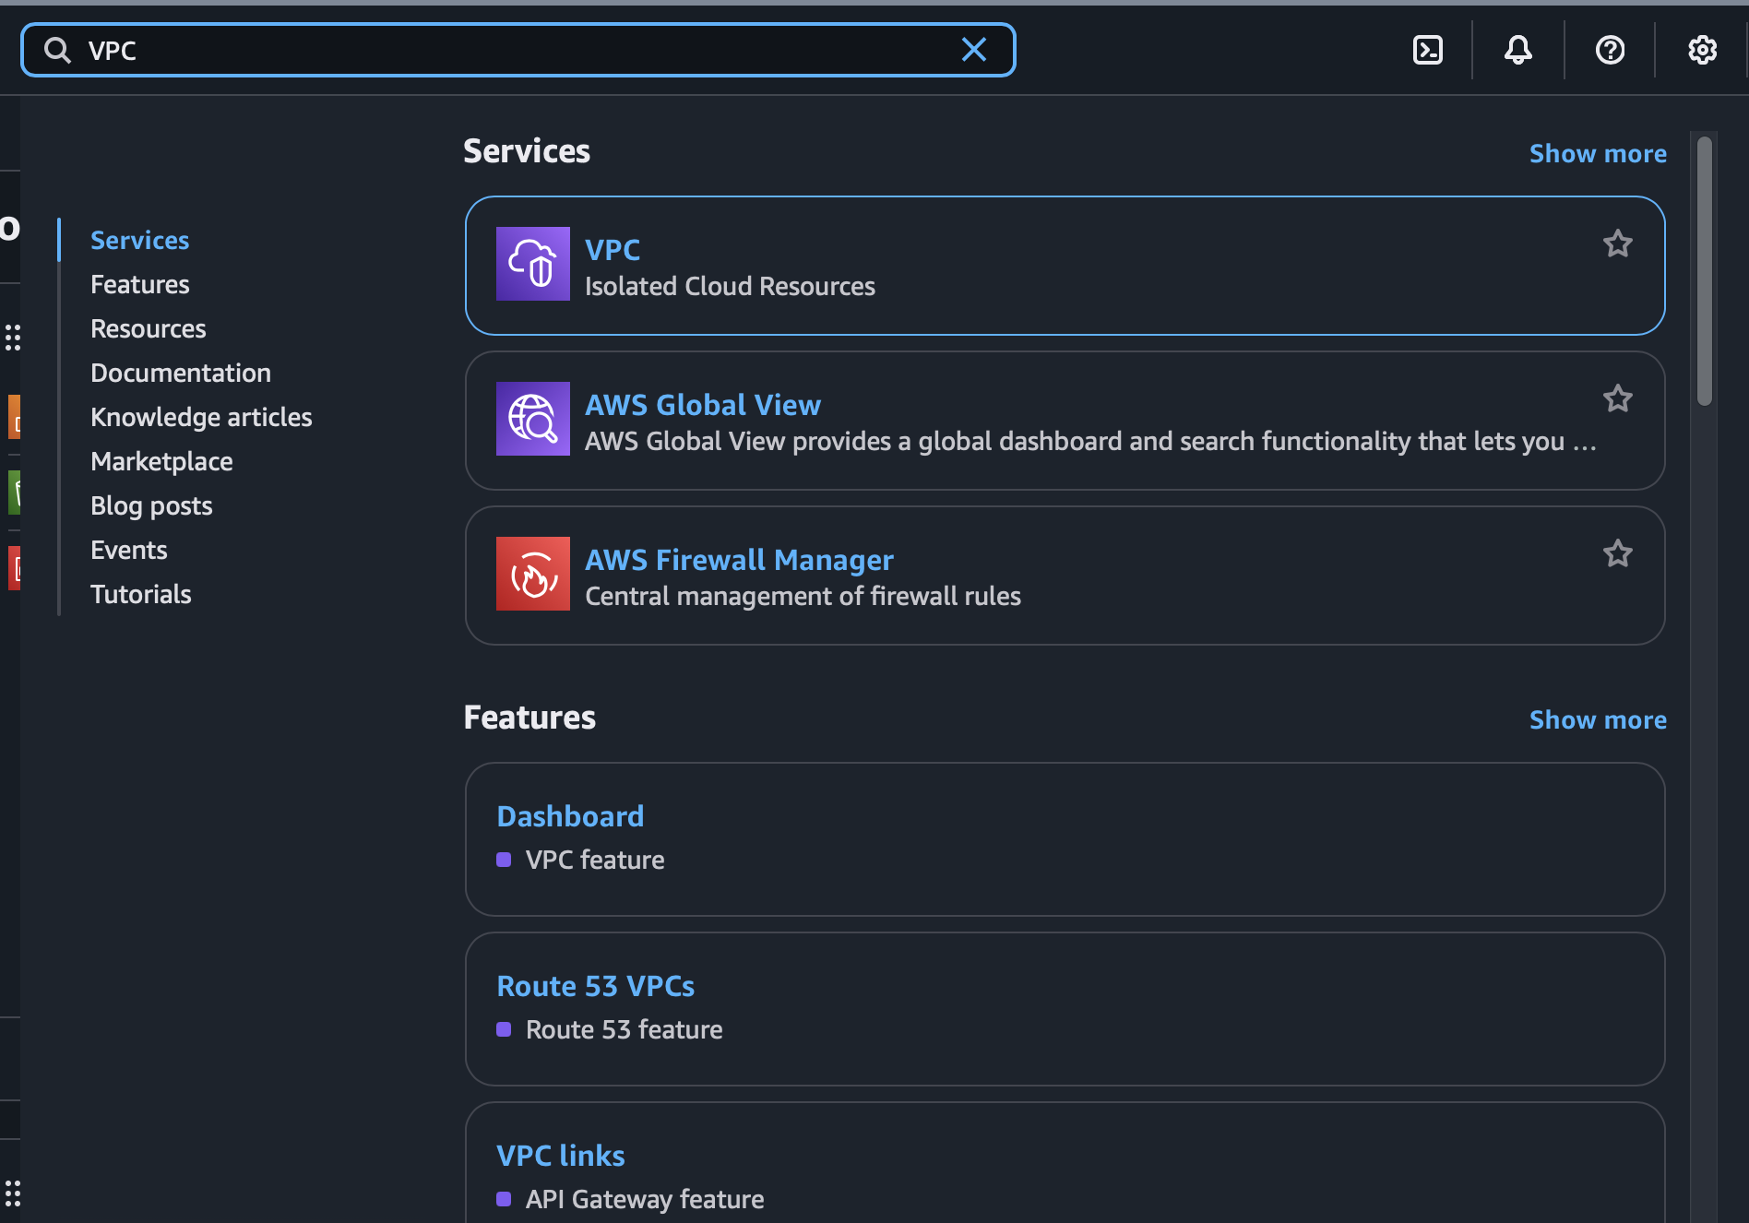

1. Launch a VPC service with a name and a Ipv4

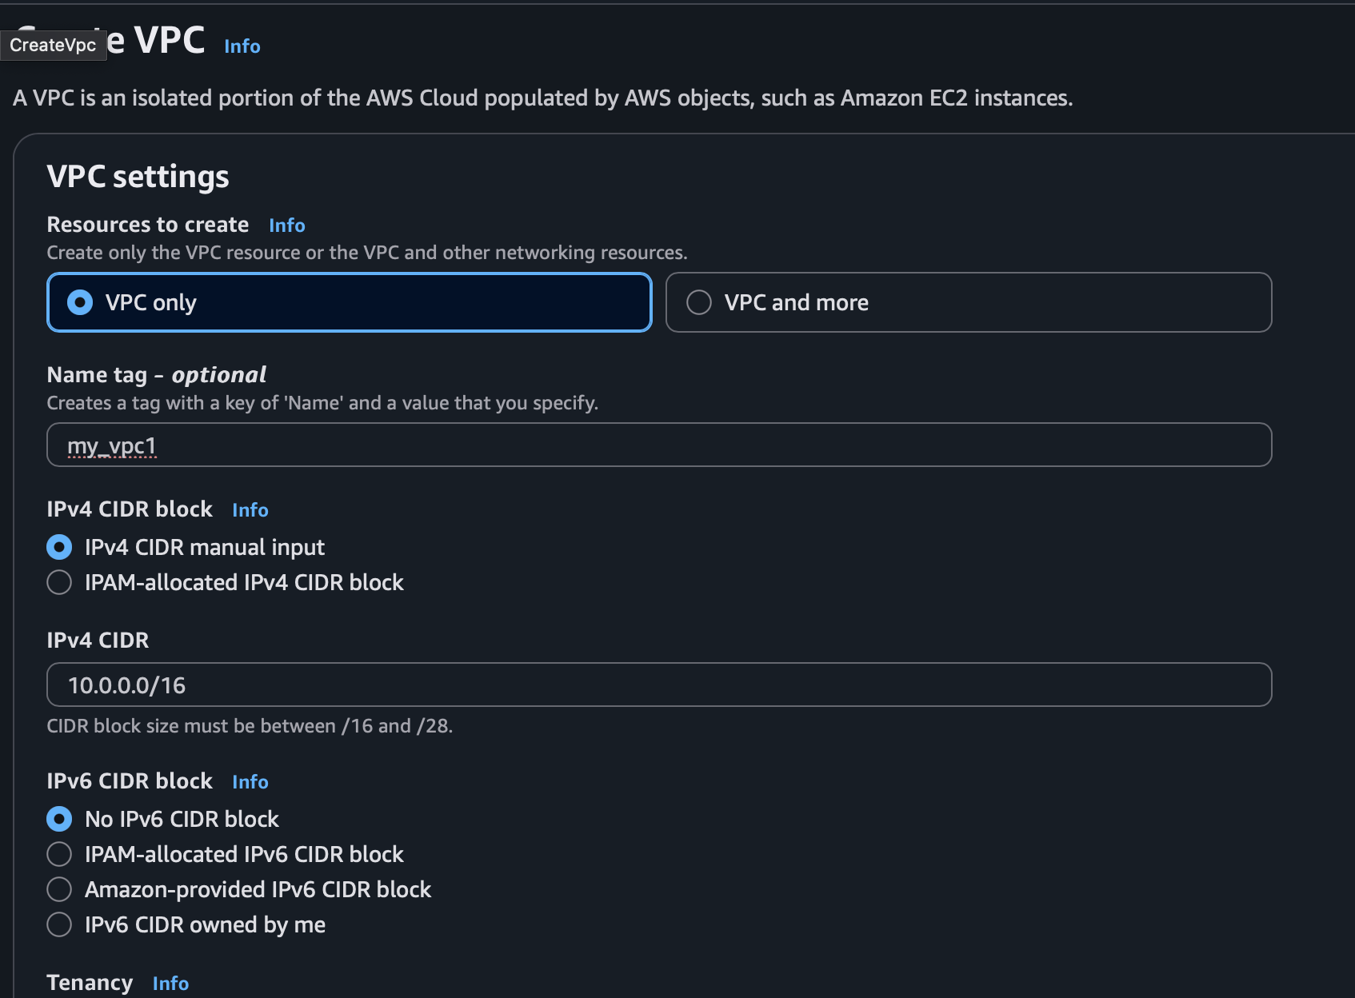

1. Go to the subnets tab under same dashboard and use the vpc you just created for vpc id than name the subnet choose a availibilty zone and also the Ipv4 for the subnet and create the subnet.

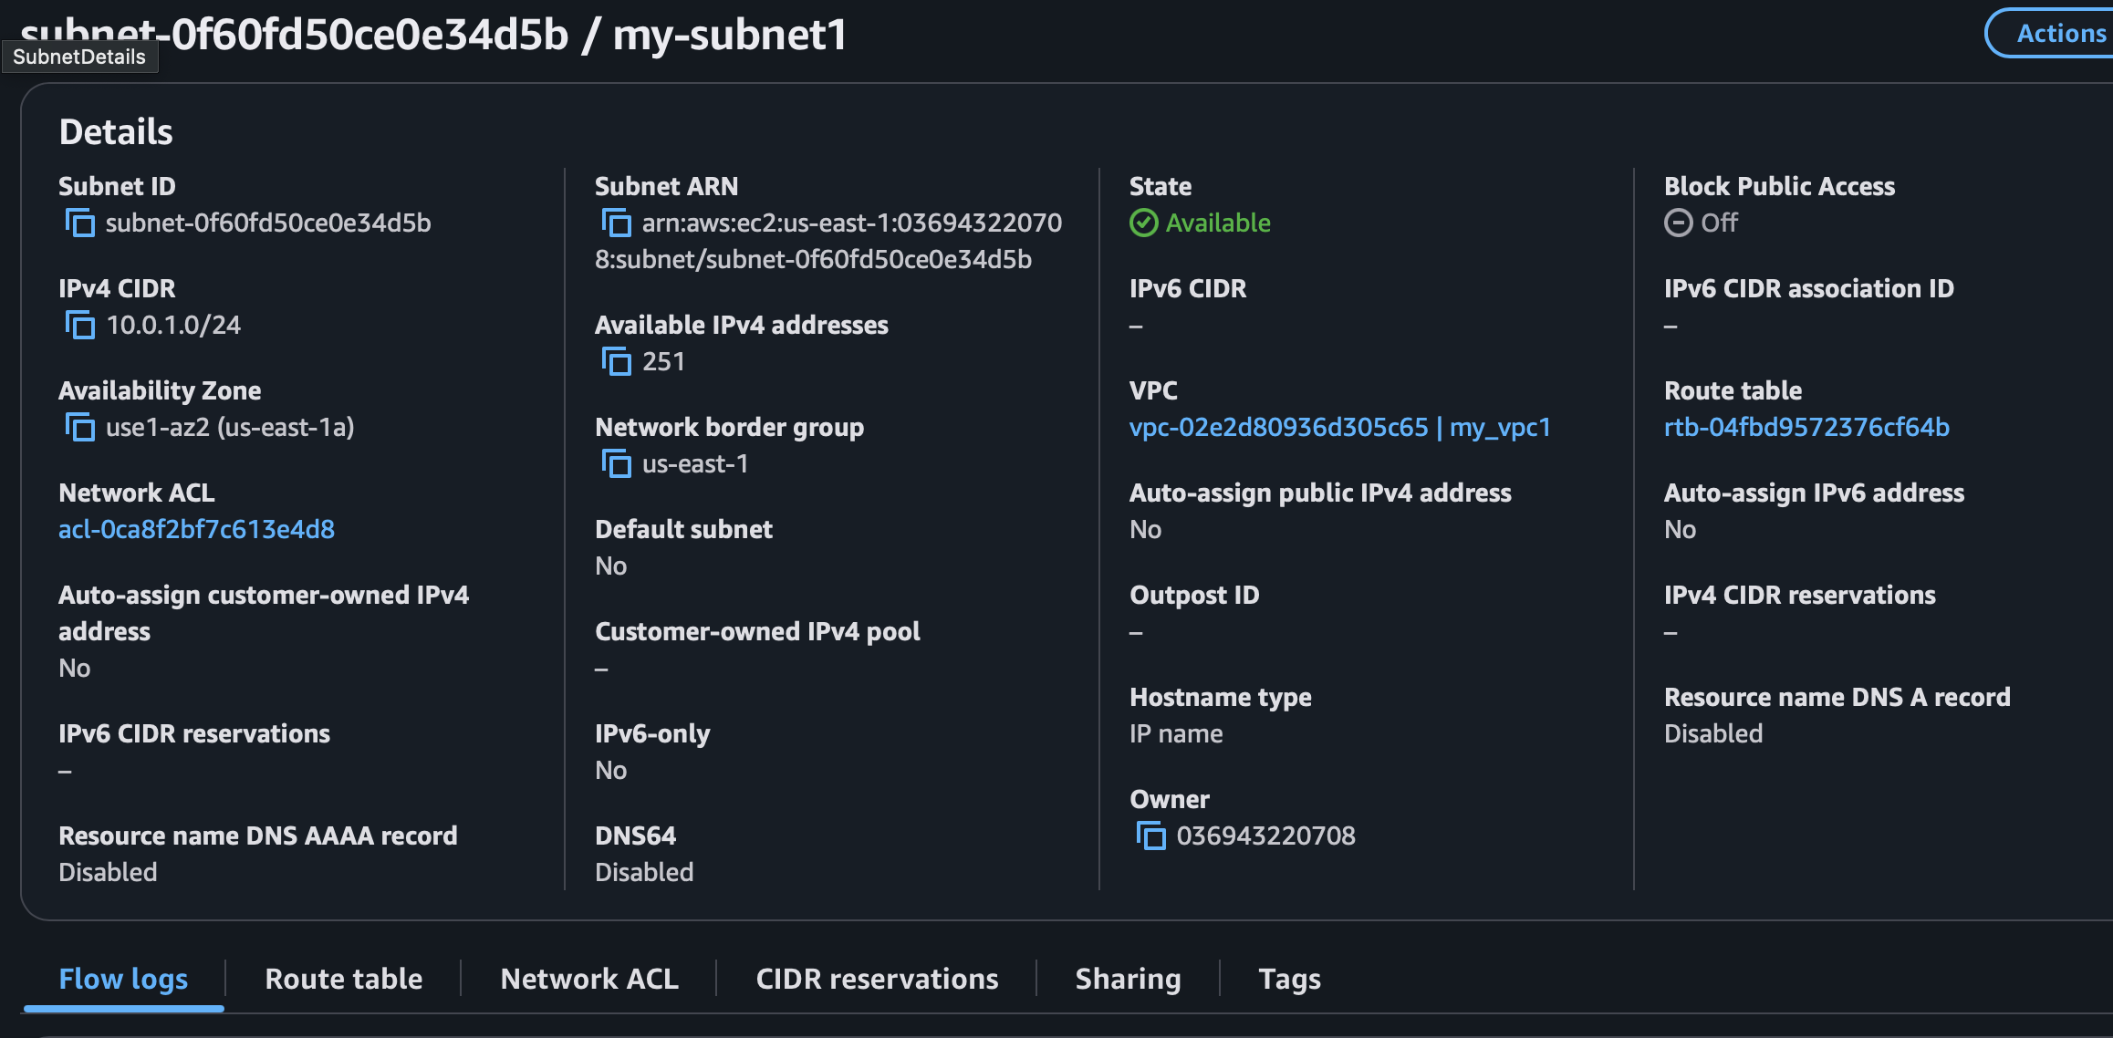

1. Move to internet gateways in under VPC name the gateway and create gateway.

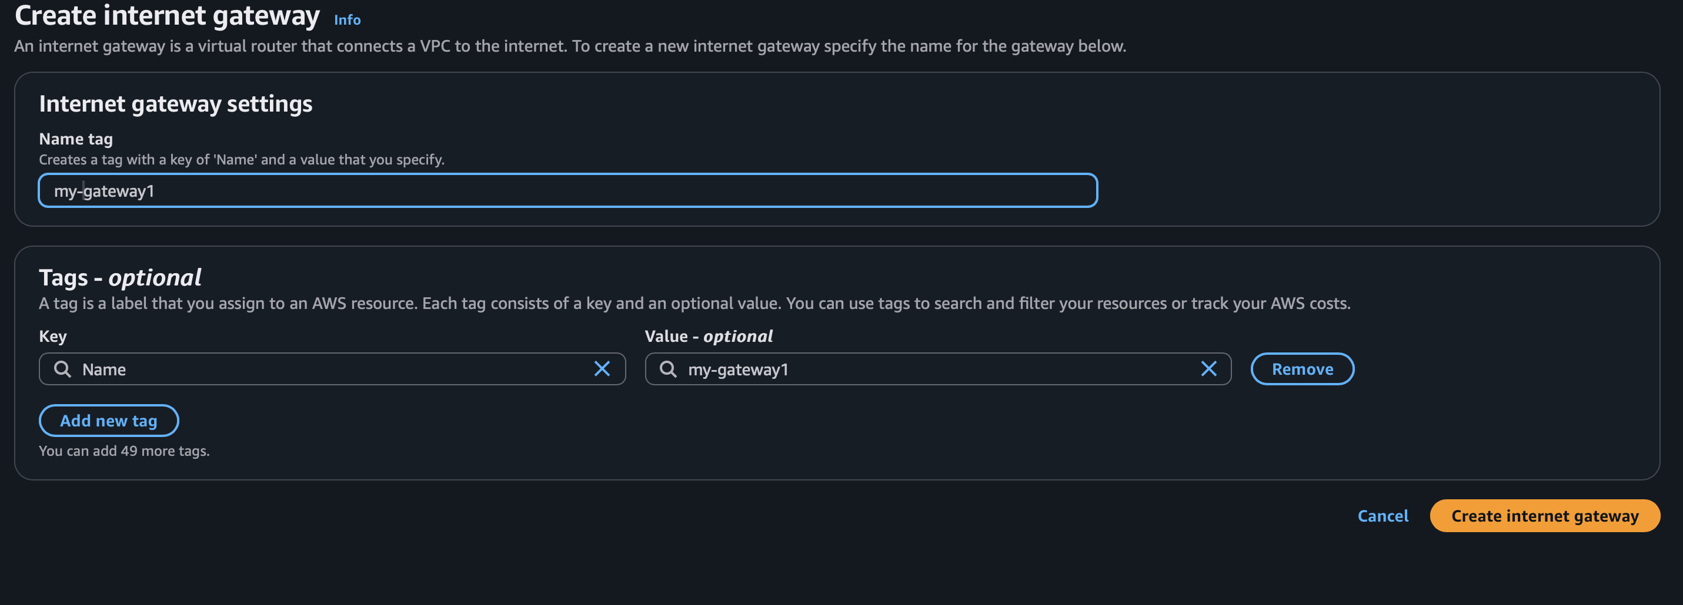

1. After its creation you will ahave a option to attach it to a VPC use the vpc you made.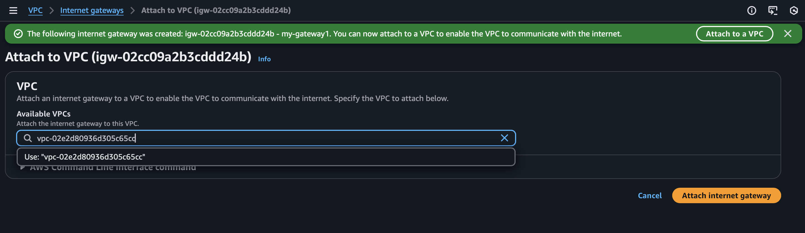
2. Now go to route tables and create a route table make a name and select the VPC

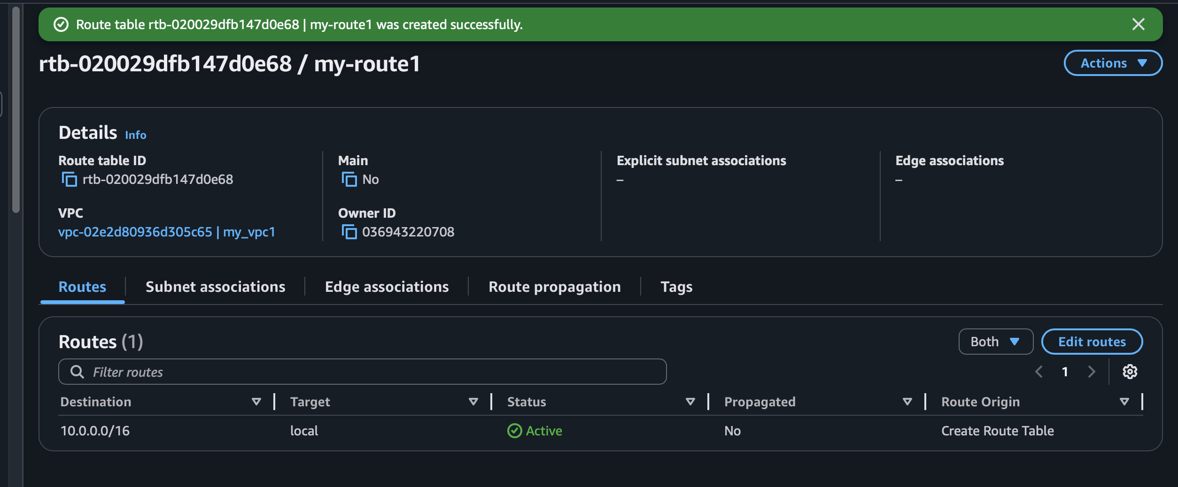

1. Now go to edit routes and click add routes select rout 0.0.0.0/0 and internet gateway then select the gateway you created and save changes.

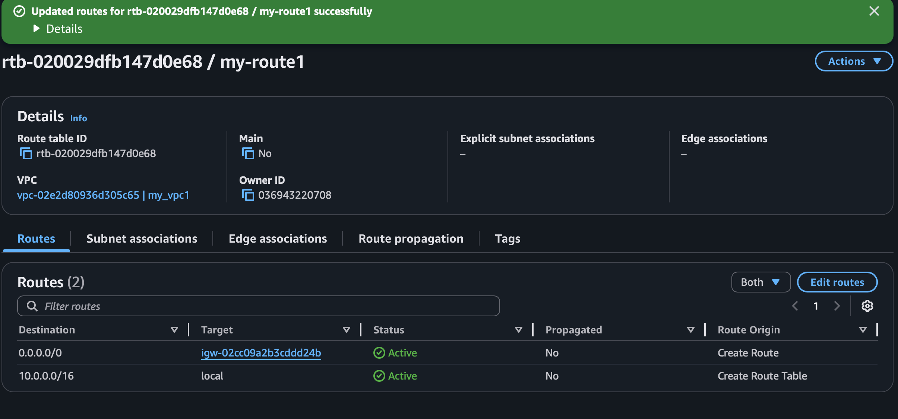

1. Now go to subnet association and select the subnet created earlier.

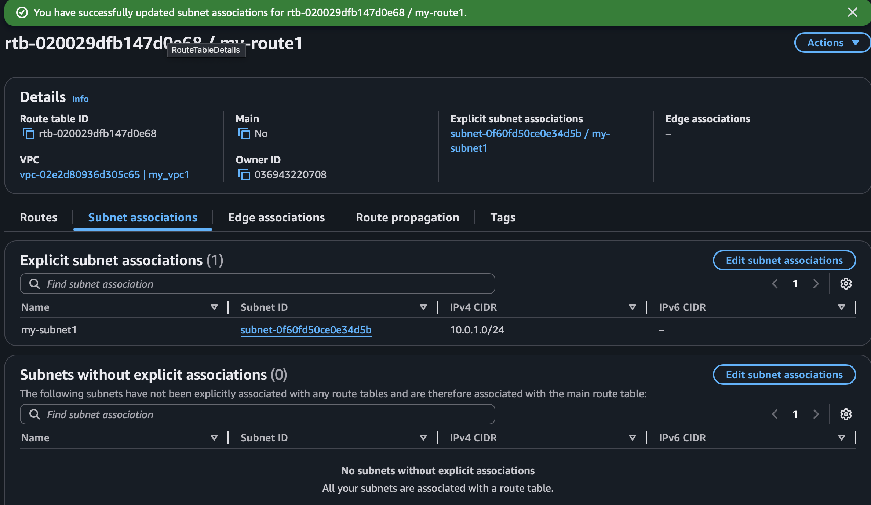

1. Now go to the EC2 services and launch instance name the EC2 service and download the key also select application as windows also in vpc and nentwok choose the vpc and network created.

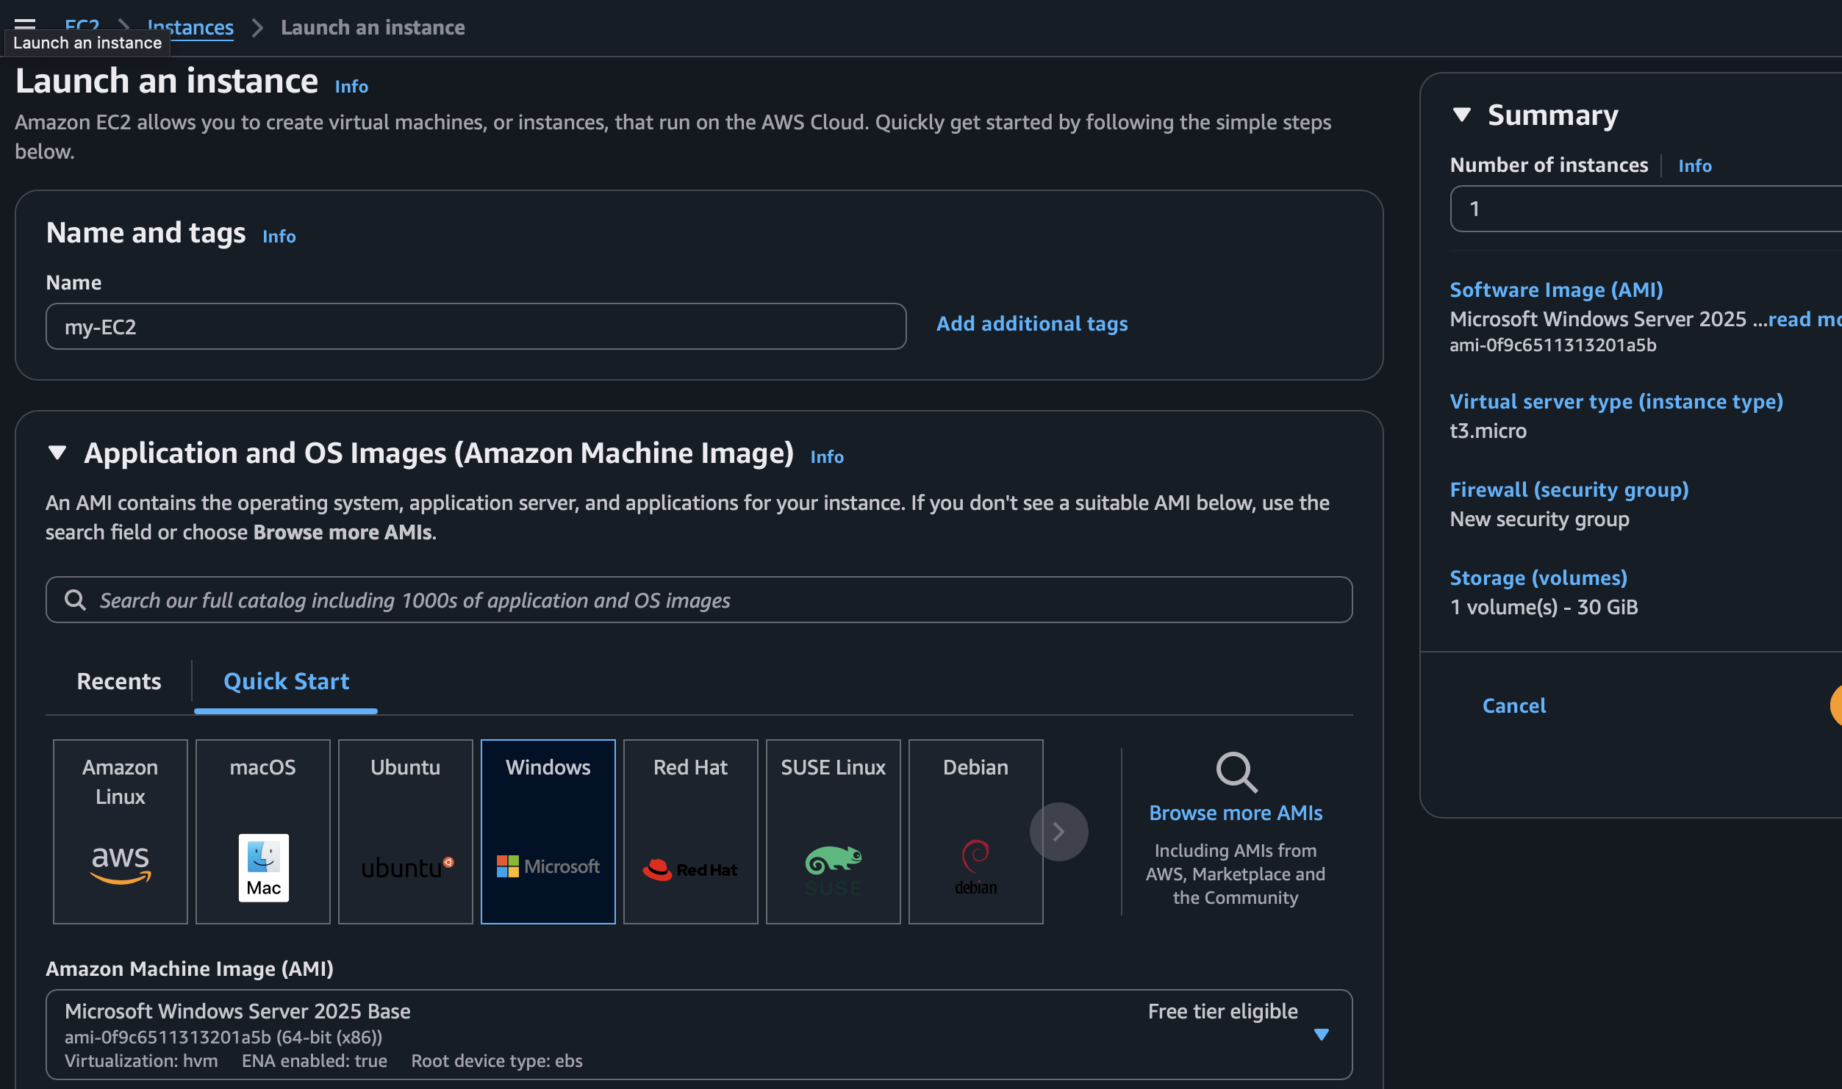

1. Now connect to to the EC2 with rdp and the .pem format key you had.

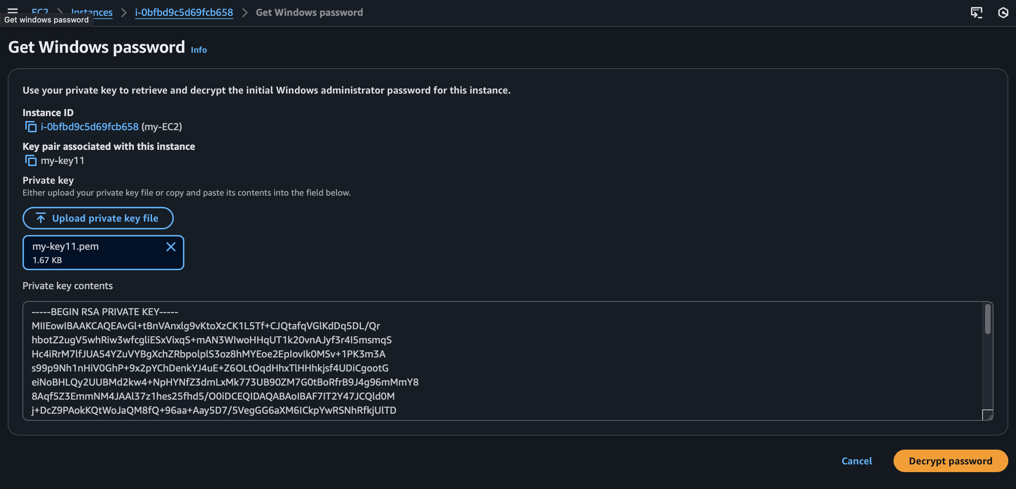

1. With the help of remote desktop connection enter your ipv4 and name :” Adminsitrator” and connect to your windows.

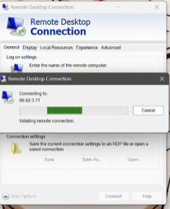

1. Your windows virtual machine will appear

